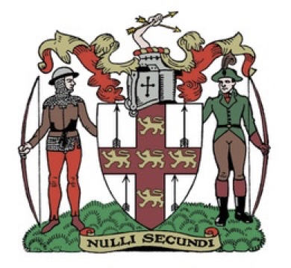Northern Counties Archery Association.

Annual General Meeting

Saturday 15th March 2025 at 11.00 am

AGENDA.

1. Welcome.
2. Apologies for absence.
3. Minutes of the previous meeting.
4. Matters of accuracy.
5. Officers reports.
   1. President.
   2. Chairman.
   3. Vice Chairman
   4. Treasurer
   5. Secretary
   6. Regional Coaching Officer
   7. Judges Liaison Officer.
   8. Junior Representative
   9. Flight Representative.
   10. Clout Representative.
   11. Field Representative.
   12. Public Relations Officer.
   13. Archery England Rep.
   14. Safeguarding Officer.
   15. AGB Development Officer.
6. Approval of audited accounts.
7. Election of Officers.

President.

All other officers agreed to stand again.

President.

Chairman. Andrew Neal

Vice Chairman Peter Gregory

Treasurer Derek Pearson

Secretary Gaynor Moorhouse.

Regional Coaching Officer Danny Cameron

Judges Liaison Officer. Sharon Tideswell

Junior Representative Vacancy

Flight Representative. Tony Bakes

Clout Representative. Andrew Neal

Field Representative. Tony Tideswell

Public Relations Officer. Elaine Jobson

Archery England Rep. Carol Bladen / Andrew Neal / Chris Battersby

Safeguarding Officer. Carol Bladen

Any other nominations for the above posts.