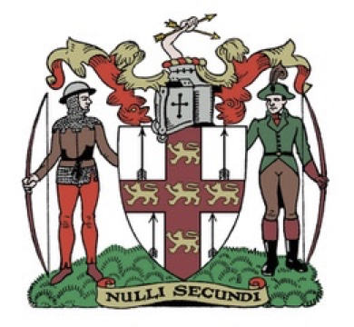Northern Counties Archery Association.

Annual General Meeting

Saturday 15th March 2025 at 11.00 am

Hello Archers:

I hope you are all well and have enjoyed shooting over the last year.

Northern Counties Archery Association would like to invite you to their AGM

**The meeting is on Saturday 15th March 2025 at 11.00 am** (Please do not arrive too early as the hall has been booked from 11.00 am)

It will be a face to face meeting and lunch will be provided.

The venue is :

The Lantern Room.

Boston Spa Village Hall.

199 High Street.

Boston Spa.

LS23 6AA

Please find attached:

* The agenda.
* Minutes of the last AGM
* Treasurers Accounts 2022/2023. To follow.

Please note a vote will be taken at the AGM on the following proposal.

To increase **archers’** affiliation fees by £1.00

Also Andrew Neal Chair will give a short presentation on the report from Archery GB on the Regions and Home Counties meeting held on Saturday 18th January 2025.

Committee reports will be sent nearer the meeting.

Please email any nominations you may have for committee positions to Gaynor Moorhouse [secretary@ncas.co.uk](mailto:secretary@ncas.co.uk) Nominations will also be taken at the AGM on the 16th March 2024.

Please send as many members/archers as you can.

I look forward to seeing you at the meeting.

Gaynor Moorhouse NCAS Secretary