



**The Third Jason Price**

**Memorial Longbow**

**Tournament in**

**Aid of Herriot Hospice**

**Double two-way Stafford**

**To BLBS Rules**

**At Baldersby Park YO7 3PG**

**What 3 words …**

**crispier.bordering.bared**

**Saturday August 16th**

**2025**

**2025**

**IN MEMORY OF DR. JASON PRICE**

**1971 - 2022**

|  |  |  |
| --- | --- | --- |
| **R0UND – DOUBLE TWO WAY STAFFORD**  **12 DOZEN ARROWS @ 32.4YDS**  **ASSEMBLE AT 10.00 AM**  **FIRST ARROW – WHEN READY**  **PRIZE LIST**  **LADIES –**  **MOST HITS – TROPHY AND MEDAL**  **HIGHEST SCORE – MEDAL**  **MOST GOLDS – MEDAL**  **GENTS –**  **MOST HITS – TROPHY AND MEDAL**  **HIGHEST SCORE – MEDAL**  **MOST GOLDS – MEDAL**  **1ST JUNIOR BOY – TROPHY AND MEDAL**  **1ST JUNIOR GIRL – TROPHY AND MEDAL**  **SHERRY AND FRUIT CAKE THROUGHOUT THE DAY**  **TEA AND BUTTIES ETC. AVAILABLE THROUGHOUT THE DAY** |  | **ENTRY FEE**  **(NON-REFUNDABLE)**  **SENIORS - £12.00 JUNIORS – £8.00**  **ENTRIES WILL BE TAKEN ON THE DAY (RING FIRST IF POSSIBLE)**  **PLEASE SEND YOUR ENTRIES TO –**  **IAN HUNTER**  **SOUTHDENE, THORNTON-LE BEANS, NORTHALLERTON,**  **N.YORKS. DL6 6SW**  **BACS PAYMENT PREFERRED**  **Acc No. 35797592 Sort code 05-09-44**  **(Please put your name and tournament as ID e g. Hunter – Jason) Tel : 07541829640**  **E MAIL : ianchunter66@hotmail.com**  **CHEQUES SHOULD BE MADE PAYABLE TO – THIRSK BOWMEN**  **In accordance with G.N.A.S Child Protection and Vulnerable Adults Policy guidelines, all persons any wishing to use any type of still photo, video, or mobile phone picture recording equipment must register their interest with the event organiser on the day of the event.**  **When you enter a competition the following information may be collected and shared with tournament organisers, scoring systems and other**  **competitors, for example : Target Lists and Results may be published, ie: First name, Surname, Gender, Bow Style, D.O.B., e-mail, phone number and club.** |

**Jason Price Stafford 2025**

**NAME ………………………………. AGE IF JNR ………….. ADDRESS …………………………………………………………..**

**POST CODE ………………….. TEL No ………………………**

**CLUB ………………………. BLBS/AGB No ………………..**

**E MAIL ………………………….@.................................**

**BANK TRANSFER ID**

**Jason Price Stafford 2025**

**NAME ………………………………. AGE IF JNR ………….. ADDRESS …………………………………………………………..**

**POST CODE ………………….. TEL No ………………………**

**CLUB ………………………. BLBS/AGB No ………………..**

**E MAIL ………………………….@.................................**

**BANK TRANSFER ID**

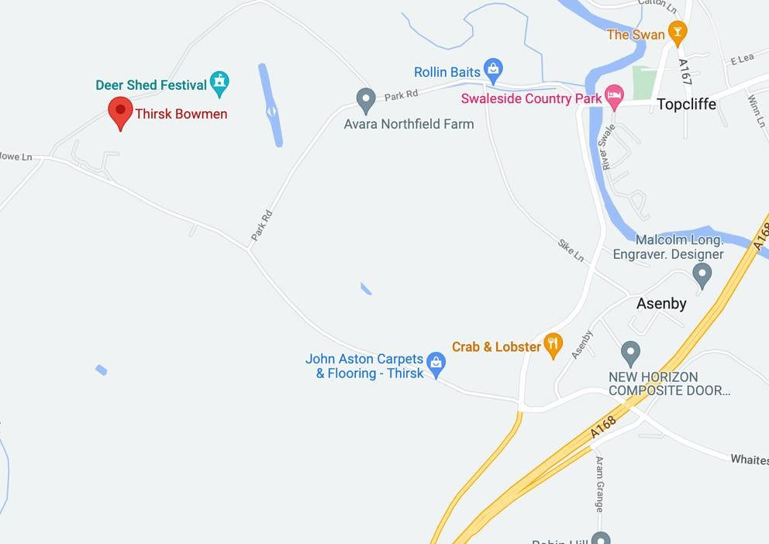

From junction 49: A1(M), take the A168 to Thirsk and Teesside. Exit at the first junction to Asenby. Take the first left to Rainton (before the Crab and Lobster) and Baldersby Park is half a mile on the right, immediately after Nursery Gardens Caravan Park.

|  |  |  |
| --- | --- | --- |
| **Jason Price Stafford 2023**  **NAME ………………………………. AGE IF JNR ………….. ADDRESS …………………………………………………………..**  **POST CODE ………………….. TEL No ………………………**  **CLUB ………………………. BLBS/AGB No ………………..**  **E MAIL ………………………….@.................................**   |  | | --- | |  |   **BANK TRANSFER ID**    **Jason Price Stafford 2023**  **NAME ………………………………. AGE IF JNR ………….. ADDRESS …………………………………………………………..**  **POST CODE ………………….. TEL No ………………………**  **CLUB ………………………. BLBS/AGB No ………………..**  **E MAIL ………………………….@.................................**   |  | | --- | |  |   **BANK TRANSFER ID** |



From junction 49: A1(M), take the A168 to Thirsk and Teesside. Exit at the first junction to Asenby. Take the first left to Rainton (before the Crab and Lobster) and Baldersby Park is half a mile on the right, immediately after Nursery Gardens Caravan Park.